**MINISTRY OF EDUCATION, CULTURE AND RESEARCH OF REPUBLIC OF MOLDOVA TECHNICAL UNIVERSITY OF MOLDOVA**

**FACULTY OF COMPUTERS, INFORMATICS AND MICROELECTRONICS DEPARTMENT OF SOFTWARE ENGINEERING AND AUTOMATICS**

Computer Architecture

***Laboratory work 2: Exercises in Logisim***

Elaborated: st.gr. FAF-213, Sirghi Tudor

Verified: asist.univ., ladislav Voitcovschi

Chis, ina˘u, 2023

# Contents:

**Introduction**. . . . . . . . . . . . . . . . . . . . . . . . . . . . . . . . . . . . . . . . . . . . . . **3**

**Exercise 1**. . . . . . . . . . . . . . . . . . . . . . . . . . . . . . . . . . . . . . . . . . . . . . . **4**

**Exercise** **6** . . . . . . . . . . . . . . . . . . . . . . . . . . . . . . . . . . . . . . . . . . . . . . . **4**

**Exercise** **11** . . . . . . . . . . . . . . . . . . . . . . . . . . . . . . . . . . . . . . . . . . . . . . . **5**

**Exercise** **16** . . . . . . . . . . . . . . . . . . . . . . . . . . . . . . . . . . . . . . . . . . . . . . . . **6**

**Exercise** **21** . . . . . . . . . . . . . . . . . . . . . . . . . . . . . . . . . . . . . . . . . . . . . . . . **6**

**Conclusions** . . . . . . . . . . . . . . . . . . . . . . . . . . . . . . . . . . . . . . . . . . . . . . . **7**

# Introduction

Logisim is a free and open-source digital design and simulation tool that allows users to create and test digital circuits using a variety of logic gates and other digital components. With its user-friendly interface and powerful simulation capabilities, Logisim is an ideal tool for students, hobbyists, and professionals who want to learn about digital circuit design or develop new digital systems.

To work with Logisim, you first need to download and install the software on your computer. Once installed, you can start a new project and begin designing your digital circuit by dragging and dropping digital components, such as logic gates, onto the design canvas. You can then connect the input and output lines of the digital components to create the desired logic function.

After designing the digital circuit, you can simulate its behavior by applying input signals and observing the output signals. Logisim provides a range of simulation tools and analysis options that allow you to test and refine your circuit's functionality. You can also save and export your circuit designs in various file formats, such as PNG, SVG, and Verilog.

Logisim supports a wide range of digital components, including logic gates, flip-flops, multiplexers, decoders, and counters, as well as more advanced features such as subcircuits and hierarchical design. By learning how to work with Logisim, you can gain valuable insight into the principles of digital circuit design and develop the skills necessary to create complex digital systems.

**Exercise 1**

Porți NOT: Construiți o porți NOT care să invertăie semnalul de intrare

Not Gate: build a NOT gate to invert the input signal

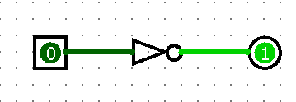

A NOT logic gate is a fundamental digital logic gate that has a single input and a single output. The gate produces an output that is the opposite of its input. If the input is high, the output is low, and if the input is low, the output is high. The NOT gate is also known as an inverter because it inverts the input signal. It is an essential building block for many digital circuits and can be used to perform logical operations such as negation and complementation.

## Exercise 6

Porți XOR: Construiți o porți XOR care să aibă două intrări și să furnizeze un semnal de ieșire "1" atunci când doar o singură intrare este "1".

XOR gates: build an XOR gate that has two inputs and provides a "1"output signal when only one entry is "1".

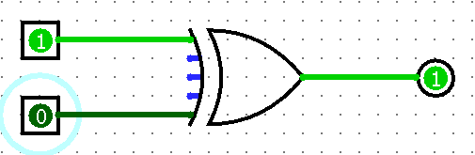

An XOR gate (also known as exclusive OR gate) is a digital logic gate that has two inputs and one output. The output of an XOR gate is high (1) when the inputs are different, and the output is low (0) when the inputs are the same. In other words, the XOR gate produces a 1 output only when exactly one input is 1. The XOR gate is commonly used in digital circuits for data comparison and error detection, as well as in encryption and decryption algorithms. It is a fundamental building block for many complex digital systems and is often combined with other logic gates to perform more complex logical operations.

## Exercise 11

Registru: Construiți un registru care să poată reține mai multi biti de date.

Register: build a register that can hold multiple bits of data.

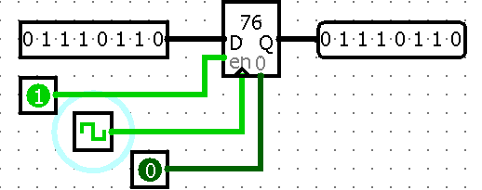

## In Logisim, a register is a digital circuit component that stores a binary value and outputs it on demand. The register typically has two inputs: a data input and a clock input. When the clock input changes from low to high, the register stores the current value of the data input. The stored value remains unchanged until the next clock edge.

## The register in Logisim can be used to store a single binary value or a sequence of binary values. For example, a sequence of registers can be connected together to form a shift register, which can shift data bits from one register to the next on each clock cycle.

## Registers are commonly used in digital circuits for temporary storage of data, as well as for synchronization and timing. They are often used in conjunction with other digital components such as counters, decoders, and multiplexers to implement more complex logic functions.

## Exercise 16

## Multiplexor cu 4 intrări: Construiți un multiplexor cu 4 intrări și două intrări de selectare

## 4-input multiplexer: build a multiplexer with 4 inputs and two selector inputs

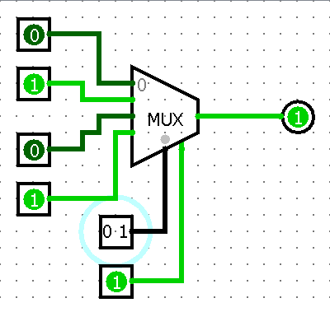

## A multiplexer (also known as a mux) is a digital circuit that selects one of several input signals and forwards it to a single output line based on the value of one or more control signals. A multiplexer has multiple input lines, a select input line, and a single output line. The select input line determines which input signal is forwarded to the output line. Multiplexers are commonly used in digital circuits for data selection and routing, as well as for signal switching and transmission. They can also be used in conjunction with other digital components, such as registers and arithmetic logic units (ALUs), to perform complex digital operations. Multiplexers come in various configurations, such as 2-to-1, 4-to-1, and 8-to-1, depending on the number of input signals they can select from.

## Exercise 21

## Flip-flop T: Construiți un flip-flop T

## Flip-flop t: build a flip-flop T

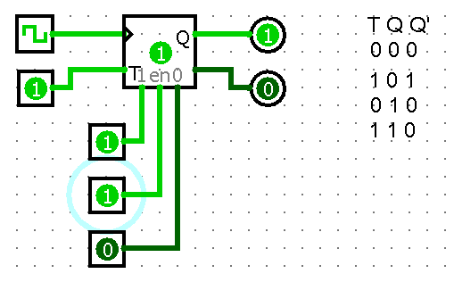

A flip-flop is a digital circuit component that stores a single bit of binary data, and the T-gate (also known as the T flip-flop) is a specific type of flip-flop that changes its state (i.e., toggles) when a "toggle" input signal is applied.

The T flip-flop has a "toggle" input (T) and two outputs: Q and Q̅ (the complement of Q). When the T input is high (1), the flip-flop toggles its state: if the current state is 0, it switches to 1, and if it is 1, it switches to 0. When the T input is low (0), the flip-flop maintains its current state.

The T flip-flop is commonly used in digital circuits for frequency division and synchronization, as well as for pulse generation and counting. It can be built using various logic gates, such as NAND, NOR, or D flip-flops with additional gates. The functionality of a T flip-flop can be simulated using digital design software, such as Logisim or Verilog, or it can be implemented using hardware components such as transistors, resistors, and capacitors.

# Conclusions

In conclusion, Logisim is a powerful digital design and simulation tool that allows users to create, test, and simulate digital circuits using logic gates and other digital components. Logic gates, such as AND, OR, NOT, XOR, and NAND, are the building blocks of digital circuits and are used to perform Boolean logic operations on binary inputs.

Digital circuits can be designed and tested in Logisim by connecting various logic gates and other digital components, such as flip-flops, multiplexers, decoders, and counters, to create complex digital systems. Logisim provides a user-friendly interface that enables users to drag and drop digital components onto the design canvas, and then simulate the circuit's behavior by applying input signals and observing the output signals.

Logisim's flexibility and versatility make it an ideal tool for digital circuit design, education, and research. Whether you are a student, hobbyist, or professional, Logisim can help you create, test, and refine your digital circuit designs. By understanding the principles of logic gates and digital circuits, you can gain insight into the operation of modern digital systems and contribute to the development of new and innovative technologies.